**PROJECT REPORT FORMAT**

**1.INTRODUCTION:**

**1.1.Project Overview:**

"Welcome to our Grocery Web App, your one-stop shop for all your grocery needs! With our user-friendly interface and wide selection of high-quality products, we aim to make your grocery shopping experience convenient and enjoyable. Whether you're looking for fresh produce, pantry staples, or household essentials, our app has you covered. Explore our virtual aisles, add items to your cart with ease, and have your groceries delivered right to your doorstep. Experience the future of grocery shopping with our Grocery Web App today!"

**1.2.Purpose:**

Our Grocery Web App is more than just a convenient way to shop for groceries—it's a comprehensive solution designed to enhance every aspect of your shopping experience. Imagine a virtual supermarket at your fingertips, offering an extensive selection of high-quality products that cater to your every need.

**2.IDEATION PHASE:**

**2.1.Problem Statement:**

The problem statement for the digital grocery experience centers around balancing convenience and cost-effectiveness while addressing challenges in supply chain management, inventory, and delivery, all while ensuring a satisfying customer experience.

**2.2.Empathy map Canvas:**

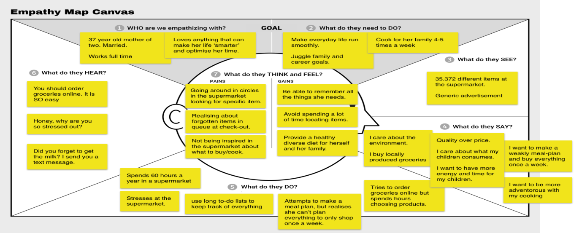

**2.3.Brainstorming:**

Brainstorming provides a free and open environment that encourages everyone within a team to participate in the creative thinking process that leads to problem solving. Prioritizing volume over value, out-of-the-box ideas are welcome and built upon, and all participants are encouraged to collaborate, helping each other develop a rich amount of creative solutions.

**3.REQUIREMENT ANALYSIS:**

**3.1.Customer Journey map:**

Customer journey map outlines a shopper’s experience from initial awareness to post-purchase, highlighting their actions, thoughts, emotions, and touchpoints at each stage.

**3.2.Solution Requirement:**

A successful digital grocery experience requires a combination of factors, including a user-friendly platform, efficient order fulfilment, and a focus on customer experience.

**3.3.Data Flow Diagram:**

It visually represents how data moves within the system, from the customer’s actions to the backend processes and data storage.

**4.PROJECT DESIGN:**

**4.1.Problem Solution Fit:**

This involves identifying pain points like time-saving, wider selection, and competitive pricing, and then providing solutions through features like online ordering, delivery, and personalized recommendations.

**4.2.Proposed solution:**

Integrating technology to enhance convenience, efficiency, and personalization for shoppers, both in-store and online.

**4.3.Solution Architecture:**

A role focused on designing and implementing technology solutions to enhance the online grocery shopping experience.

**5.PROJECT PLANNING&SCHEDULING:**

**5.1.Project Planning:**

1.Market research and analysis

2.Business planning

3.Technology and Platform

4.Operations and Logistics

5.Marketing and Promotion

6.Continuous Improvement

**6.FUNCTIONAL AND PERFORMANCE TESTING:**

**6.1.Performance Testing:**

It involves evaluating how the system behaves under different load conditions to ensure a smooth and efficient user experience.

**7.RESULTS:**

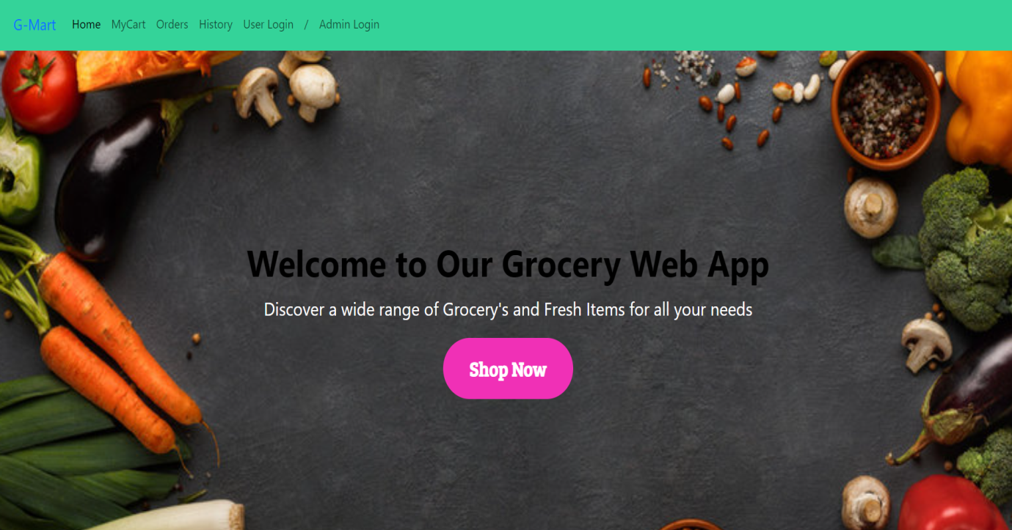

**8. ADVANTAGES&DISADVANTAGES:**

**Advantages:**

*Convenience and Time Savings

*Accessibility

**Disadvantages:**

*No Physical Inspection

*Potential for Fraud and Security Risks

*Delivery Issues

**9. CONCLUSION:**

It was evolving to prioritize customer convenience and personalization through technology integration, data-driven strategies, and a focus on seamless omnichannel experiences.

**10. FUTURE SCOPE:**

It significant growth and transformation, driven by increased customer demand for convenience, personalization, and faster delivery. Key trends include AI-powered personalization, advanced fulfillment technologies, omnichannel integration, and the rise of voice-activated shopping.

**11. APPENDIX:**

**The demo of the app is available at:-**

<https://drive.google.com/file/d/1HLowcIqs2d8lxTprS2jqPmR4AOnUW8xD/view?usp=drive_link>

**Github& Project Demo Link:**

https://github.com/purrukavith/Shopsmart-your-digital-Grocery-store-experience-